**Financial Wellbeing Education Programme for Employees**

Motivating and retaining your employees is fundamental to the long-term success of a business. The wellbeing of employees is widely recognised as contributing significantly to the success of a business.

With Coronavirus currently having a huge impact on businesses and the way employees work, wellbeing at work has never been more important. Many employees will be under a huge amount of stress, especially around their finances and the future uncertainty we are facing.

These online financial wellbeing workshops have been developed to help employees understand their own current financial circumstances and empower them to make informed decisions regarding their finances now and in the future; helping to potentially reduce any financial stress.

At the core is **four interactive workshops** to engage your employees and allow them time to relate to their own situation. The 1-hour online workshops cover the different life and career stages, helping employees to consider their own circumstances and financial goals, highlighting and explaining the things they might encounter and the options open to them:-



The wellbeing workshops are delivered by Lisa Vaughan, Director of Lisa Vaughan Financial Planning Ltd, who has been through an in-depth workplace accreditation process, ensuring she has the expertise and ability to deliver engaging and interesting content.

The employee feedback we gather highlighting attendee numbers, subsequent follow-up meetings and individual comments can provide valuable MI with which to reinforce your commitment to employee wellbeing.

**Key Areas Covered Include:**

* Budgeting and Understanding Money
* Mortgages and Re-mortgaging - Getting onto and moving up the property ladder
* Protection - Financially protecting your income, home and family in the event of death or serious illness
* Savings & Investment Planning - Tax efficient ways to build future wealth
* Existing Pension & Investment Reviews - Helping your plans to stay on track and you know your options
* Retirement Planning - Assessing the income required in retirement or semi-retirement
* Inheritance Tax and Family Wealth Planning - Ensuring your family’s wishes are carried out and assets are transferred through the generations tax-efficiently
* Redundancy support

**Next Steps**

If you would like to discuss financial wellbeing workshops for your employees now or in the future then please contact Lisa Vaughan via telephone 07570 068 039, email [lisa.a.vaughan@sjpp.co.uk](mailto:lisa.a.vaughan@sjpp.co.uk) or web [www.lisavaughanfp.co.uk](http://www.lisavaughanfp.co.uk)

 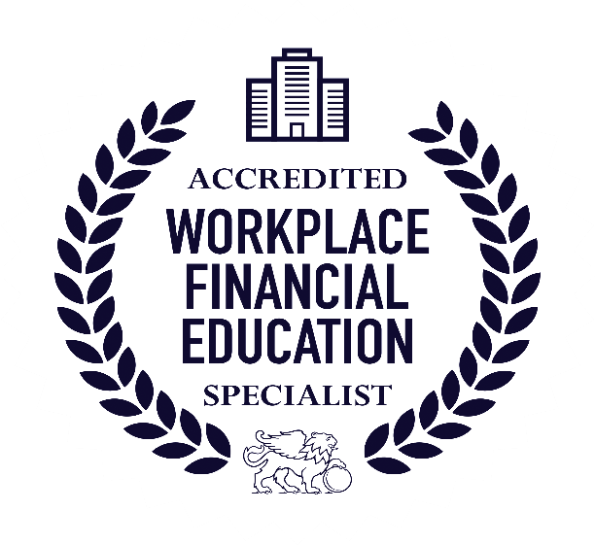

Lisa Vaughan Financial Planning Ltd is an Appointed Representative of and represents only St. James's Place Wealth Management plc (which is authorised and regulated by the Financial Conduct Authority) for the purpose of advising solely on the group's wealth management products and services, more details of which are set out on the group's website [www.sjp.co.uk/products](http://www.sjp.co.uk/products)